V.Balaji, Shiva Harini.S, Swetha.S, Siddhtarth.D
SURFACE RUN-OFF MANAGEMENT

V.Balaji Department of Information Technology Easwari Engineering college, Chennai, India (e-mail: balaji.iniyan@gmail.com ).
Shiva Harini.S. Department of Information Technology Easwari Engineering college, Chennai, India (e-mail: hariniprakash2601@gmail.com)
Swetha.S Department of Information Technology Easwari Engineering college, Chennai, India (e-mail: sswetha169@gmail.com).
Siddhtarth.D Department of Information Technology Easwari Engineering college, Chennai, India (e-mail: siddhtarthdeena@gmail.com).

ABSTRACT
We deploy a multi-parameter sensor-based automation farming because the current way of manually monitoring agricultural fields has several drawbacks. The Smart Agriculture Monitoring System was created utilizing IOT technology. The Arduino Uno, temperature humidity sensor, soil moisture sensor, water level sensor, barometric pressure sensor, water pumps, and DC motors power this system. When the smart agriculture monitoring system is activated, the sensors detect the field's water level and soil moisture level. If the water level falls below the level indicated for a certain crop grown in the field, the system will automatically activate the water pump. The IOT notifications regarding current water level, soil moisture level, and motor starting will be presented on the LCD display module. We may also access the pump manually via a website. Farmers will also receive this information through cell phone. By pushing the system's given button, the user can violently halt the water flow in the field. When implemented, this method will aid farmers in maintaining proper soil moisture and water levels, hence enhancing crop output with minimal effort.

Keywords:
Internet of things (IOT), Sensor based Automation farming, Smart agriculture monitoring system, wireless sensor networks (WSNs)

INTRODUCTION
Surface runoff is the untamed flow of water over the ground surface, in contrast to channel runoff (or stream flow). It happens when excessive precipitation, stormwater, meltwater, or other sources can no longer enter the soil at a sufficient pace. This might happen when the soil is saturated with water to its maximum capacity and rain falls faster than the soil can absorb it. Surface runoff is common due to certain imper-meable surfaces (such as roofs, crevices and pavement) prevent water from soaking into the ground. Furthermore, runoff can occur either through natural or man-made mechanisms. Surface runoff is a vital part of the water cycle. It is the principal cause of soil erosion caused by water. A drainage basin is a geographical region that produces runoff that drains to a common place. Surface runoff may erode the Earth's surface, and degraded debris can be deposited a long distance away. Water erosion causes four kinds of soil erosion: splash erosion, sheet erosion, rill erosion, and gully erosion. The mechanical contact of raindrops with the soil surface causes splash erosion: soil particles that are displaced by the impact migrate with the surface runoff. Sheet erosion is the movement of silt overland by runoff in the absence of a well-defined channel. Because of the roughness of the soil surface, runoff may get concentrated into smaller flow routes; when they incise, the small but well-defined channels that emerge are known as rills. These channels can range in size from one centimeter to many meters. If runoff continues to incise and increase rills, they may develop into gullies. Gully erosion may convey a considerable volume of eroded material

in a short period of time. Crop production is often reduced as a result of erosion, and these impacts are investigated in the discipline of soil conservation. The soil particles delivered in runoff range in size from.001 millimeter to 1.0 millimeter. Larger particles sink during short transit lengths, whereas microscopic particles can be transported floating in the water column over long distances. Erosion of silty soils with tiny particles causes turbidity and reduces light transmission, disrupting aquatic habitats. The main environmental challenges related with runoff are the effects on surface water, groundwater, and soil caused by the movement of water contaminants to these systems. These repercussions eventually translate into human health risks, environmental disruption, and an aesthetic influence on water supplies. Petroleum compounds, herbicides, and fertilizers are among the pollutants that have the greatest influence on surface waterways as a result of runoff. The quantitative absorption of pesticides and other pollutants by surface runoff has been researched since the 1960s, and interaction of pesticides with water was recognized to increase phytotoxicity early on. Drinking water aesthetics are compromised when surface water impacts are used as potable water supplies. In addition, it modifies the metabolic processes of the aquatic species they support; these adjustments might result in mortality, such as fish kills, or affect the population balance. Animal mating, spawning, egg and larval viability, juvenile survival, and plant yield are also affected. According to some study, surface runoff of pesticides such as DDT can change the genetic gender of fish species, transforming male fish into female fish. Many areas in the state had severe rainfall in the recent 24 hours, which ended at 6 a.m. on Saturday, with Sirkazhi in Mayiladuthurai district receiving the most. (44cm). The district received 25cm of rain on average. Over 30,000 hectares of standing paddy fields in the district have been flooded by rains. The overnight rainfall reported in Sirkazhi was the greatest ever recorded in the coastal district in the previous 122 years, according to the India Meteorological Department (IMD). The severe rain that lasted for 16 hours in town has disrupted power delivery in remote hamlets and destroyed a bridge.

EXISTING SYSTEM
Are manually monitored farming actually beneficial? What difference does automation farming make with respect to time, cost and efficiency? Currently, agriculture fields are being monitored manually around several parts of the world. Huge number of resources are being consumed due to the lack of sensors. Micro-catchment runoff farming water harvesting is a method of collecting surface runoff from a small catchment area and storing it in the root zone of an adjacent infiltration area/basin. This infiltration area/basin may be planted with annual crops, or with a single tree or bush. Although the catchable area should be free of vegetation and requires labour force for proper maintenance.

Limitations of Existing System
- Huge amount of water resources is being consumed.
- Monitoring the field manually requires large amount of labor force.
- As a result, this can be expensive in the long run.

LITERATURE SURVEY
Smart Farming Technologies (SFTs) can increase productivity while lowering costs and conserving resources; nevertheless, farmers are reluctant to use them. A framework called technology acceptance model (TAM) is used to determine the factors affecting the farmer’s intentions to adopt the two types of SFT’s and analyzed. As a result, the fast rise of SFTs has stimulated study in a variety of fields. These topics include the appraisal of these technologies, the creation of acceptable applications for them, demographic trends of their use, and the economic and environmental advantages they provide. There has been little investigation into the function of sources of information regarding SFTs and their relationship with the two essential components of the TAM, the perceived ease of use (PEU) and perceived usefulness (PU). The most successful way to improve the intention to use these technologies is to engage cooperative extension service agents and vendors, the most prevalent change agents in Italian agriculture, to promote information campaigns and training activities.[1] Federica Caffaro et al. 2020
Hydroponics may be grown in both a green house and a glass house. The restriction in a greenhouse setting is maintaining a constant temperature, pressure, and humidity level. Monitoring PH value and electrical conductivity in hydroponics is also a difficulty that must be checked and maintained. Manual monitoring is used, which is a trivial; otherwise, the plants would die off. The initial goal of this project is to automate the monitoring of the greenhouse environment. IOT is utilized to transport the recovered data to the internet (mass storage), and mobile apps are used to convey the current status to the user through the internet to their mobile phones, allowing for simpler monitoring and maintenance. The preliminary testing of the irrigation control approach suggest that it is a viable alternative to the currently existing irrigation and nutrient delivery management systems. The irrigation is tuned using a solely feed forward loop. Because feedback is solely utilized to tune the model parameters, instabilities caused by feedback loop delays are avoided. The concept is already being used on commercial production sites to examine grower reactions and operational data from various crops. [2] Dr.D. Saraswathi et al. 2020
Agriculture being a significant part of the economy across the world is entitled for a technological advancement. With the help of internet of things (IOT) and wireless sensor networks (WSNs), new methodologies of monitoring soil health, moisture content leading to the design and development of FarmFox-an Iot device, that analyses the information obtained from the sensors to the user via the internet. This is a cost effective and an economic alternative for sustainable agriculture that is fully automated such that the farmers can incorporate different agricultural parameters to make smart decisions [3] Anirbit Sengupta et al. 2021
Rising water issues and the need for better methodologies is the utmost priority for farm maintenance. A monitoring system that tackles problems such as soil erosion, over irrigation and crop specific irrigation problem is developed for an easy and efficient management of agricultural practices. A distributed wireless sensor network that is spread across the form with different sensor modules that transmits data on a common server. Based on the Internet of Things, a sustainable and a computationally profitable strategy is proposed. [4]. Anneketh Vij et al. 2020
An innovative IOT based farm management system that utilizes wireless communication for detecting soil, environmental and crop parameters along with weather forecast to predict future farming practices established on a software model of agronomic models. The use of low-cost wireless electronic modules for gathering data from linked sensors connects classic cropping techniques with novel technology. The fertigation system is powered by a low-cost solar-powered WSN capable of constantly monitoring soil and environmental parameters; thanks to sensor nodes strategically placed in cultivated land or greenhouse, interest parameters of both air and soil are detected and transmitted to an on-cloud database, allowing monitoring and remote control from enabled users. (Farmer or agronomist). The developed platform enables common users or potential buyers to obtain traceability information for agri-food products throughout the supply chain, providing them with added value and thus a higher economic return for the farmer; in this way, customers can ascertain the production process of considered agri-food and their quality standards even before placing a purchase order. Finally, the planned agricultural facility was thoroughly tested on the field to ensure appropriate performance of the hardware and software parts, as well as proper operation of the control programs available on smartphones for enabled users. [5]. P. Visconti et al. 2020
In order to improve the quality and productivity of agricultural produce an approach that utilizes smart sensors in monitoring, visualizing generating digital data thereby adding value in soil-less farming through automation. The fundamentals of smart sensors are explored, as well as the most practical sensors for monitoring soil and plant physicochemical parameters in field cultivation procedures, greenhouses, and indoor hydroponics. Precision farming, agro machinery automation, Precision Livestock Farming (PLF), TV White Spaces (TVWS) remote connectivity, Unmanned Aerial Vehicles (UAVs) based imagery, and IoT application can assist farming communities in using resources accurately based on real-time farm data acquired and improving crop yield without wastage. Issues such as lack of arable land, skilled manpower, shortage of water changing weather conditions leading to expensive, low yield and an unprofitable agricultural practice that is tackled by the use of data driven technologies in a digital-physical farm management cycle. [6]. Kenny Paul et al. 2022
With the rise in world population, shortage of food being the most crucial problem that needs to be addressed by endorsing alternatives to improve the capacity of the soil and the safety of the environmental resources. The development of cost-effective miniscule sensors and processors resulting in a practical and an attainable smart farming practice. In conclusion, IoT-based farming has yet to be properly utilized to meet the difficulties of food to a rising global population with dwindling arable lands and thus limit human involvement and labor. IoT-based farming combined with big data has the potential to provide a worldwide solution to both indoor and arable farming. IoT-based farming represents a large development opportunity for one of the most advanced technologies. It combines sensor, embedded computer, current network, wireless communication, and distributed information processing technologies to give us with a new approach to acquire massive data for in-depth analysis and automation of the complete agricultural system for improved produce quality and quantity. [7] Hira Farooq et al.2020
An extensive and scalable network architecture using cloud computing and wireless sensors based on throughput maximization, latency minimization, high signal-to-noise ratio (SNR), minimum mean square error, and improved coverage area corroborating to better performance than conventional strategies of farming. Based on the agriculture field situation, the parameter values of sensor conditions such as temperature, humidity, and wetness may be fixed. The suggested approach will maximize resource consumption and alleviate the problem of irrigation scarcity. The graphical depiction of WSN significant performance outperforms prior technologies that could be retrieved and visually shown. In the future, there will be animal incursion. To safeguard crops and farmers against animal assaults, a detection system can be deployed. Using IoT technology, real-time field monitoring is feasible. The suggested technique rigorously supervises agricultural resource waste.[8] P. Sanjeevi et al. 2020
Sensors capture real-time atmospheric data, which is then analyzed using artificial intelligence (AI) algorithms to make gadgets act more intelligently. The revolution of modern agriculture techniques using IoT & AI over the traditional agriculture methodologies are making farming a profitable venture. Several issues go unnoticed in Indian farming such as, farmers still being dependent on seasonal rainfall and do not use any technological irrigational facility due to a lack of financial assistance. Farmers are also unable to implement automated tools for farming due to the high cost of hardware. Lack of smart and technological skills is also a major constraint in modern agriculture. The combination of this technological advancement will result in decrease of the farmer's crop production stress and reliability
unanticipated weather forecasting patterns, as well as a decrease in the cost of human labor [9]. N Aggarwal et al. 2021
To meet the needs of information monitoring for actual large-scale agricultural farms, a low-cost, low-power, and low-data-rate solution is provided. A small-scale farm is simple to operate. A large farm, on the other hand, will necessitate the automation of equipment that adds to agricultural production. Sensor-based soil property measurement is essential in creating a fully automated agricultural farm, and it also produces better results than any human technique. Existing information monitoring systems are inefficient in terms of greater deployment costs and a restricted communication range for large-scale agriculture fields. To increase the communication range, a tree-based communication method is used, with intermediary nodes added. A solar panel, a rechargeable cell, a microprocessor, a moisture sensor, and a communication unit are all included in each sensor node. This paper provides an information monitoring technique for gathering field data across vast distances in a fully automated agricultural farm. A network mechanism for the HC12 module is built in this system to extend the communication range. An experiment on a real farm demonstrates that the technology works better on soil measuring across a larger region. [10]. Muhammad Saqib et al. 2020

PROPOSED SYSTEM
For the assessment of any specific area, four environmental parameters—temperature, humidity, ambient light intensity, and soil moisture content—were captured using a total of three sensors, including an air temperature and humidity sensor, a light intensity sensor, and a soil moisture sensor. The technique for gathering data gives the chance to precisely examine the ecological conditions in the agriculture sector. Additionally, the system's adaptability enables additional monitors, such as a pH sensor to estimate plant nutrients, a UV sensor to determine the intensity of ultraviolet light, a greenhouse gas and pressure sensor to track the composition of the surrounding air, a rain sensor to detect rainy weather, and a water level sensor to identify flooding in the area. Arduino UNO microcontroller is used to interface with the sensors and to the communication devices. The temperature sensor and humidity sensor are used to monitor the weather condition on the agriculture field area. The soil moisture sensor and water level sensor are used to monitor the soil moisture and water level. The LCD is used to display the updated value from the sensors. The IOT module ESP8266 is used to update the information of sensors to the cloud. The end result can be monitored in webpage. The water pump motor is activated based on the soil moisture level by automated or manually controlled from the webpage. The one pump motor is used to store the excess water in agriculture field and another pump motor is used to provides the water when the agriculture field needs the water. Using sensor-based technology, we progressively collect the necessary information from the field area. The embedded system sensors and microcontroller assist the user in gathering information and updating the information on the LCD. Temperature, humidity, soil moisture, and water level sensors are used to collect data. The pump motor condition ON/OFF is determined by the soil moisture and water level readings. If the soil is dry, the pump motor will activate and provide the crop's needs. If there is water in the soil, the pump motor will not turn on. The pump motor condition ON/OFF is determined by the soil moisture and water level readings. If the soil is dry, the pump motor will activate and provide the crop's needs. If there is water in the soil, the pump motor will not turn on. Monitor the field area from anywhere in the globe with our remote location. And we can receive all of the sensor data from the homepage. The farm field will be maintained based on sensor results. One pump motor is used to store extra water in the agricultural field, while another pump motor is used to supply water when the agriculture field requires it.

System Flow Diagram
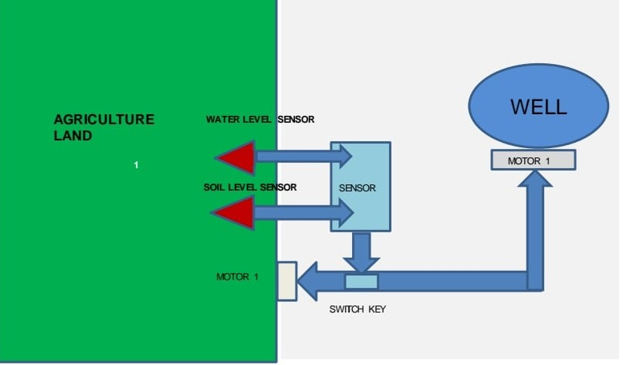

Fig.4.1 Flow Diagram

Using sensor-based technology, we progressively collect the necessary information from the field area. The embedded system sensors and microcontroller assist the user in gathering information and updating the information on the LCD.
Temperature, humidity, soil moisture, and water level sensors are used to collect data. The pump motor condition is then ON/OFF dependent on the soil moisture and water level measurements. If the soil is dry, the pump motor will activate and provide the crop's needs. If there is water in the soil, the pump motor will not turn on. Monitor the field area from anywhere in the globe with our remote location. And we can receive all of the sensor data from the homepage. The farm field will be maintained based on sensor results. One pump motor is used to store extra water in the agricultural field, while another pump motor is used to supply water when the agriculture field requires it.

Arduino Uno
Arduino is an open-source electronics platform with user-friendly hardware and software that is capable of reading inputs such as a light on a sensor, a finger on a button, or a Twitter post and converting them into outputs such as actuating a motor, turning on an LED, or publishing anything online. You may direct your board by delivering a series of instructions to the board's microcontroller. Over the years, Arduino has served as the brain of hundreds of projects, ranging from simple household products to complicated scientific equipment. A global network of agriculture field, Pump motor storage tank, pump drive. Makers - students, amateurs, artists, programmers, and professionals - have flocked around this open-source platform, and their contributions have built up to an astounding quantity of accessible information that may be of tremendous assistance to both novices and specialists. Arduino was created at the Ivrea Interaction Design Institute as a simple tool for rapid prototyping intended for students with no prior experience with electronics or programming. As the Arduino board gained popularity, it began to evolve to meet new demands and problems, transitioning from basic 8-bit boards to solutions for IoT applications, wearables, 3D printing, and embedded settings. All Arduino boards are totally open-source, allowing users to create them on their own. Arduino microcontrollers come pre-programmed with a boot loader, which facilitates program uploading to the on-chip flash memory. The optiboot bootloader is the Arduino UNO's default bootloader. A serial link to another computer is used to load programme code onto boards. A level shifter circuit is used on certain serial Arduino boards to convert between RS-232 logic levels and transistor-transistor logic (TTL) level signals. Current Arduino boards are programmed over USB, which is accomplished with USB-to-serial adaptor chips such as the FTDI FT232. Some boards, such as later-model Uno boards, replace the FTDI chip with a separate AVR chip that has USB-to-serial firmware that can be reprogrammed through its own ICSP connector. Other variations, such as the Arduino Mini and the unauthorized Boarduino, make use of a removable USB-to-serial converter. Arduino has been utilized in millions of different projects and applications because to its easy and accessible user experience. The Arduino software is simple to use for novices yet powerful enough for expert users. It is compatible with Mac, Windows, and Linux. It is used by teachers and students to create low-cost scientific equipment, to demonstrate chemistry and physics principles, and to get started with programming and robotics. Designers and architects use it to create interactive prototypes, while musicians and artists use it for installations and to test out new musical instruments.
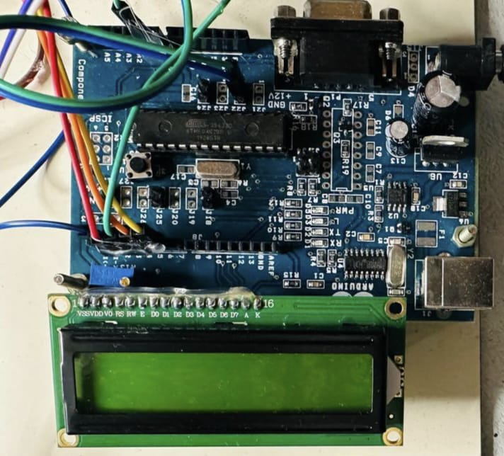
Fig.4.2.1 Arduino

Power Supply
The most important component is the power supply. It should provide a steady output regulated power supply to ensure the project's success. A 0-12V/1 mA. This is accomplished by the use of a transformer. The primary of this transformer is linked to the main power supply through an on/off switch and a fuse to safeguard against overload and short circuit. The secondary is linked to the diodes, which convert the 12V AC voltage to the 12V DC voltage. And then filtered by capacitors before being regulated to +5v by IC 7805.

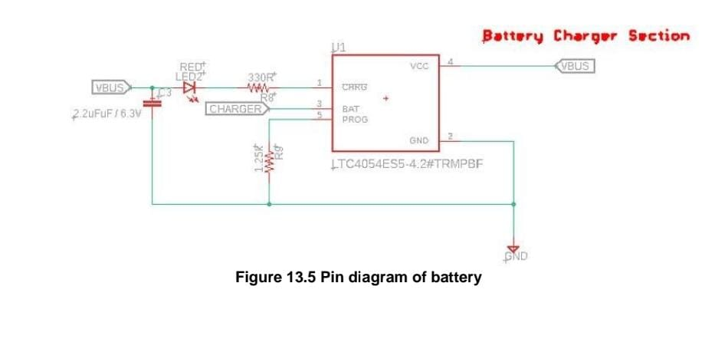

Fig.4.3 Power supply

4.4 Liquid Crystal Display (LCD)
LCD screens are electronic display modules that have a broad variety of uses. A 16x2 LCD display is a relatively simple module that is widely utilized in a variety of devices and circuits. These modules outperform seven segment and other multi segment LEDs. The reasons for this are as follows: LCDs are inexpensive, readily programmable, and have no restrictions for showing unique and even bespoke characters (unlike in seven segments), animations, and so on. A 16x2 LCD can display 16 characters per line and has two such lines. Each character is presented in a 5x7 pixel matrix on this LCD. This LCD contains two registers: Command and Data. The command register holds the LCD's command instructions. A command is an order provided to an LCD to do a preset action such as initializing it, clearing its screen, setting the cursor location, controlling the display, and so on. The data register holds the data that will be shown on the LCD. The data is the ASCII value of the character to be shown on the LCD. Learn more about the internal construction of an LCD by clicking here. We see LCD monitors all around us. Computers, calculators, television sets, mobile phones, and digital watches all employ some type of display to show the time. An LCD is a type of electronic display module that employs liquid crystal to generate a viewable image. The 162 LCD display is a relatively simple module that is often used in projects.
4.5. DHT11 sensor
This DHT11 Temperature & Humidity Sensor has a temperature & humidity sensor complex with a calibrated digital signal output. It has a very simple design with high accuracy. It offers great dependability and outstanding long-term stability by employing an innovative digital-sign-acquisition approach as well as temperature and humidity monitoring technology. This sensor contains a resistive-type humidity measurement component and an NTC temperature measurement component, and it links to a high-performance 8-bit microcontroller, providing great quality, rapid response, anti-interference capability, and cost-effectiveness. Each DHT11 element is precisely calibrated in the laboratory. The humidity calibration is exceedingly precise. The single-wire serial interface allows for rapid and straightforward system integration.
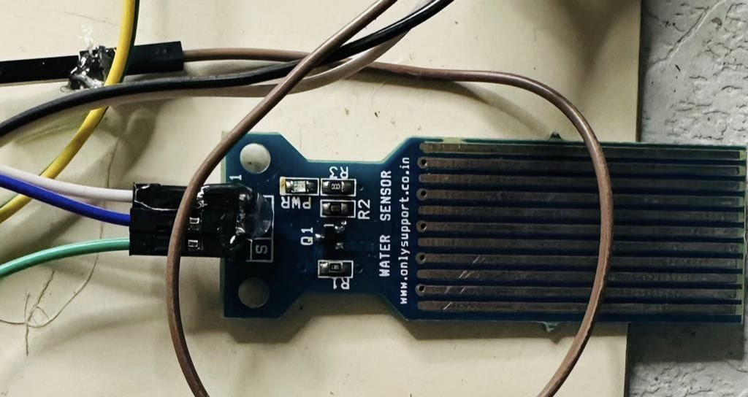
Fig.4.4 DHT11 sensor

4.6. Soil Moisture Sensor
This sensor may be used to test the moisture of soil; when there is a water scarcity in the soil, the module output is high; otherwise, the output is low. Using this sensor, one may automatically water a flower plant or any other plant that requires automated watering. Soil moisture sensors determine the volumetric water content of soil. Because direct gravimetric measurement of free-soil moisture necessitates the removal, drying, and weighing of a sample, soil moisture sensors indirectly assess volumetric water content by using another feature of the soil, such as electrical resistance, dielectric constant, or interaction. Using neutrons as a substitute for moisture content. This sensor is made up of two parts: a fork-shaped probe that must be nailed to the ground and an electrical module that will link the probe to Arduino. It requires a 3.3V or 5V power, which is controlled via the VCC and GND pins. When we are feeding, the red LED will light up. The pin AO will give us an analogue signal between the supply value to 0V (for Arduino UNO 5v to 0V) to higher humidity value will be higher, this is due to the operation of the probe because the higher the humidity is greater conductivity of the soil and thus increase the value that we measure. The DO pin will output a digital signal of "1" when the humidity value is lower than the setting set on the potentiometer and "0" when it is higher. As the probe signal, the potentiometer is coupled to a comparator LM393. To operate it appropriately, we must calibrate it with different soil samples at varying humidity levels. The green LED will assist us in this endeavor since it will light on when we have a 1 in DO. This digital soil moisture sensor is simple to operate. Simply place the sensor into the soil and it will measure the moisture or water level content. It produces a digital output of 5V when the moisture level in the soil is high and 0V when the moisture level is low. The sensor features a potentiometer for adjusting the moisture threshold. When the sensor detects more moisture than the preset threshold, the digital output rises and an LED illuminate. When the soil moisture is less than the specified threshold, the production stays low. To sense the moisture level, connect the digital output to a microcontroller. The sensor also produces an analogue output that may be coupled to the ADC of a microcontroller to determine the precise moisture content in the solid. This sensor is ideal for water gardening projects, water sensing, and so on.

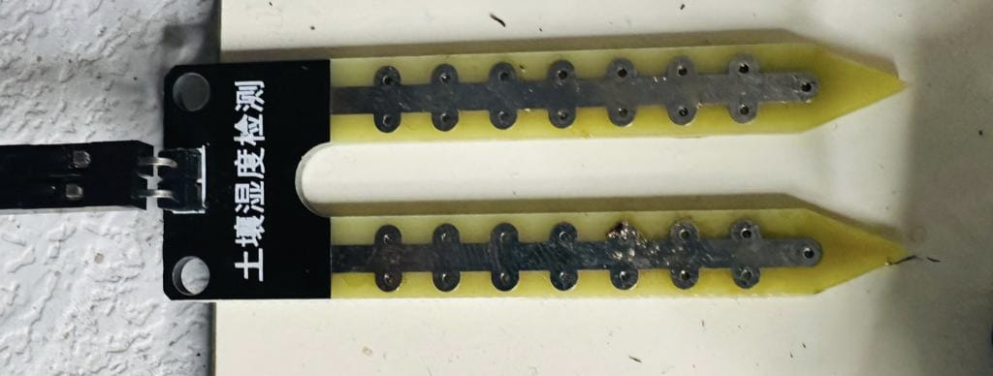

Fig.4.5 Soil Moisture Sensor

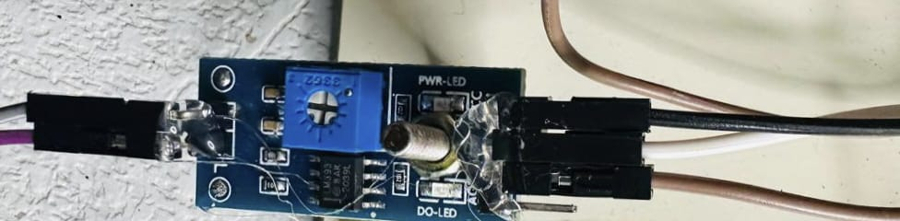

Fig 4.6 Potentiometer

4.7. Water Level Sensor

A water level sensor is used to measure the amount of water in a tank or other piece of equipment. We need to detect the level of water in our daily lives, such as in a water tank on the roof that is not easily accessible, and in labs where a certain level of any liquid must be monitored. A water level sensor is extremely useful in such situations. In today's article, we'll look at how to connect a water level sensor to a computer. Arduino and how to use this setup to monitor a certain water level. The output of a water level sensor is voltage. This circuit will tell us approximately how much of the sensor is covered by liquid. Liquid level sensors are utilized in a wide range of applications. They are widely used in vehicles, which require on a variety of fluids to function, such as checking the quantity of gas in the car, windscreen washer fluid, and oil levels. In general, they are used to measure the level of any form of fluid in a system. As a result, being able to study, operate, and design circuits using them is tremendously useful.
The liquid level sensor we'll be using is an analogue sensor, which means it outputs an analogue voltage proportional to the amount of liquid it's exposed to. To read the analogue value, we simply connect the analogue pin, denoted by an S, to an analogue pin on the Arduino board. The sensor, as seen in the accompanying figure, has a sequence of parallel wires running across the board. These lines detect the liquid level to which the board is exposed. If there is water or another fluid covering all of the wires on the board, it will produce the maximum analogue value reading. Because analogue values read by an Arduino vary from 0 (lowest reading) to 1023 (highest reading), an Arduino will read 1023 for a board entirely submerged in liquid. The Arduino will read a reading of roughly 512 if the board is partly covered. If a liquid cover 1/4 of the board, the Arduino will read roughly 256. If there is no liquid on it at all, a near-zero reading should be obtained.

Fig.4.7 Water Level Sensor

4.8. Motor Driver Ic
Common DC gear head motors require current more than 250mA. There are several integrated circuits available, such as the ATmega16 Microcontroller and 555 timers IC. However, the IC 74 series cannot deliver this level of current. When the motor is connected directly to the o/p of the aforementioned ICs, they may be damaged. To address this issue, a motor control circuit that can operate as a bridge between the aforementioned motors and ICs is required. (Integrated circuits). There are several methods for creating an H-bridge motor control circuit, including the use of a transistor, relays, and L293D/L298. An H-bridge is fabricated with four switches labelled S1, S2, S3, and S4. A positive voltage is provided across the motor when the S1 and S4 switches are closed. This voltage is inverted by opening the switches S1 and S4 and shutting the switches S2 and S3. This allows the motor to operate in reverse. The H-bridge motor driver circuit is often used to reverse the direction of the motor as well as to break the motor. When the motor comes to a halt abruptly because the terminals of the motor are shorted. When the motor is disconnected from the circuit, let it run freely to a halt.
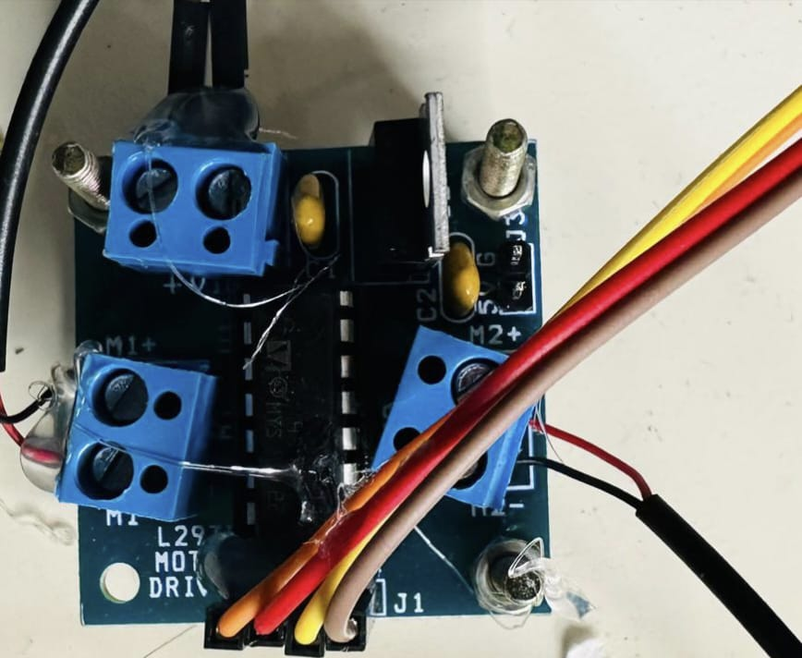

Fig.4.8 Motor Driver IC

4.9 Water Pump Motor

A pump motor is a type of DC motor that transfers fluids. A direct current motor is a device that transforms direct current electrical power into mechanical power. A direct current (DC) motor operates on the principle that when a current carrying conductor is put in a magnetic field, it feels torque and has a propensity to move. This is referred to as driving activity. Pumps use energy to produce mechanical work by moving fluid and are powered by some mechanism (usually reciprocating or rotational). Pumps employ a variety of energy sources, including manual labor, electricity, motors, or wind power, and they come in a variety of sizes, ranging from minuscule for use in medical applications to enormous industrial pumps.

4.10 ESP-12E BASED NODEMCU

The ESP8266 is the name of a Espressif Systems microcontroller. The ESP8266 is a self-contained Wi-Fi networking device that may act as a bridge between existing microcontrollers and Wi-Fi, as well as execute self-contained applications. This module includes a built-in USB connection as well as a wide range of pin-outs. You may attach the NodeMCU devkit to your laptop and flash it exactly like an Arduino using a micro-USB cord. It is also immediately breadboard compatible. Ai-thinker Team created the ESP-12E Wi-Fi module. Tensilica L106 integrates industry-leading ultra-low power 32-bit MCU micro, with the 16-bit short mode, Clock speed support 80 MHz, 160 MHz, supports the RTOS, integrated Wi-Fi MAC/BB/RF/PA/LNA, on-board antenna in lower module sizes. The module supports IEEE802.11 b/g/n agreement and a full TCP/IP protocol stack. Users can add networking modules to existing devices or design a new network controller. ESP8266 is a high integration wireless SOC developed for mobile platform makers with little space and power. It offers unrivalled flexibility to incorporate Wi-Fi capabilities into other systems or to act as a standalone application at the lowest cost and with the least amount of space required.

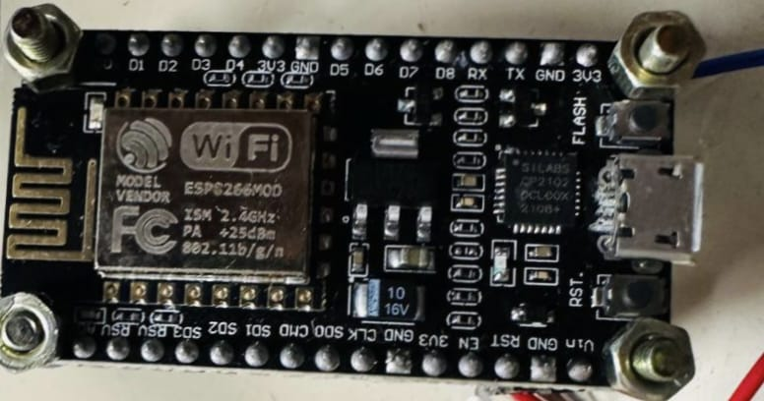
Fig 4.9 Node MCU

System Implementation
Implementation can be understood from Fig.5 which is the block diagram representation. In our system we initially focused on detecting whether the person being approached is a normal person or an autism person, because prevention is better than cure. The persons being approached are children from very younger age if they were not been treated properly then this disorder would create larger problem in activities. This system would say whether the person is normal or autistic and after found being autistic this would say its level. Even, this system provides learning modules for those kids and help them to improve their level in it. Different types of sensors are used like Eye blink sensor, Heart beat sensor, EEG sensor. Heart beat sensor using pulse rate sensor which is connected outside the VR Glass. The Eye blink sensor will be connected with the Wi-Fi module inside the VR Glass. The Eye blink count will be stored in the think speak cloud. The Eye movements, whether eyes are opened or closed will be displayed in the think speak cloud. The eye movements data will be stored in the cloud in the 0’s and 1’s form. 0 means eyes are opened and 1 means eye are closed. The actual data will be compared with this cloud data and the values are downloaded in excel sheets for further classification. The Pulse rate sensor and eye blink sensors will be connected with the Wi-Fi module. The heartbeat rate and the eye movements will be stored in the think speak cloud. The heartbeat rate will be displayed as a graph with date & time and the eye blink will be monitored. All the data will be get stored in the cloud and upcoming sensor rates also get stored in this cloud. The actual data will be compared with this cloud data and the values are downloaded in excel sheets for further classification. We have used Arduino board for the hardware sensor connections. Then using the EEG Sensor, Brain waves (alpha, beta, gamma, theta, delta) signals are collected and used for classification purpose. For the person with Autism there will be increased signal of theta, beta, gamma and delta and will be decreased signal of alpha. These data will be stored in the Think Speak cloud. Using these data and comparing with the normal data, the person can be accurately found whether he is autistic person or normal person. Then the classification will happen if they are found to be an autistic person.
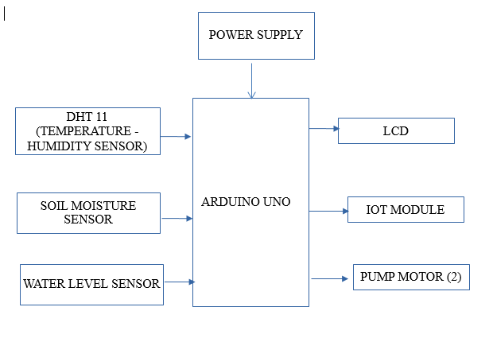
Fig.5 Block Diagram
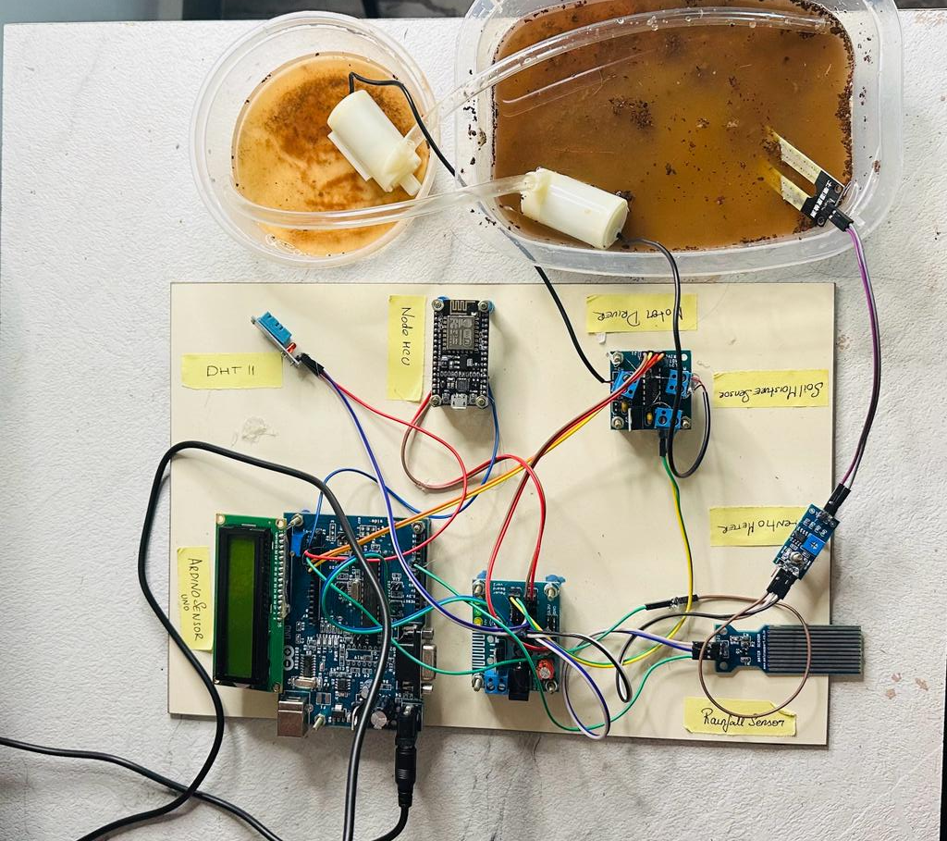
Fig.5.1 Depicts the arrangement of the aforementioned components
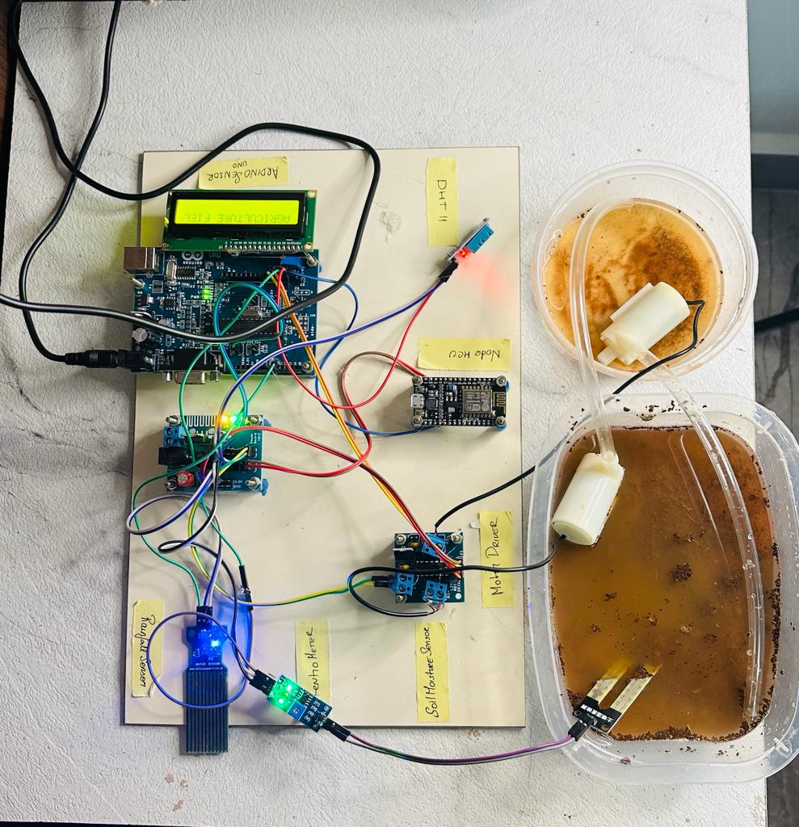
Fig.5.2 Depicts the sensors detecting the moisture level and the humidity level to pump water in or out of the agricultural field


Fig 5.3 Implementation of the obtained values in adafruit

6. PERFORMANCE EVALUATION

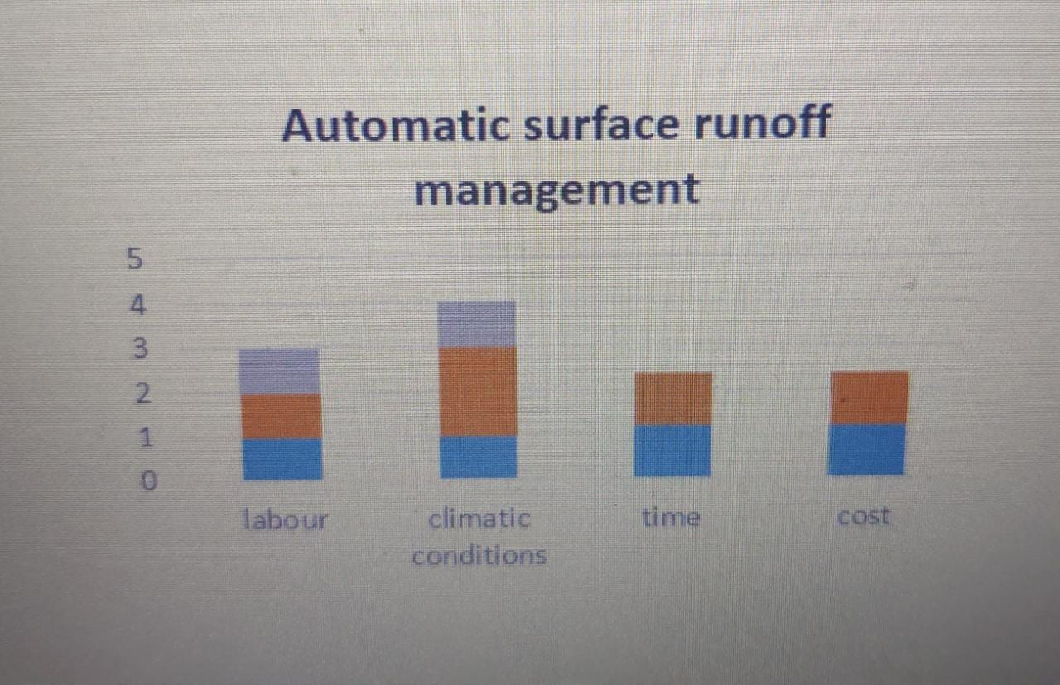

In this fig it represents the automatic surface runoff management.
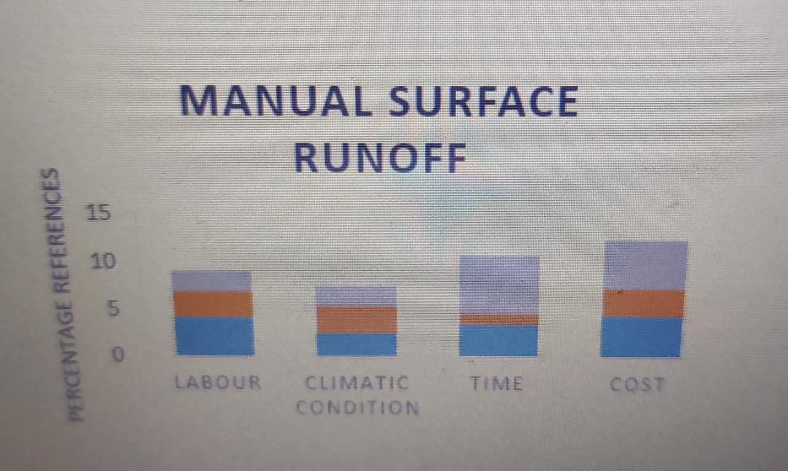

In this fig the graph represents the manual surface runoff management.

9.CONCLUSION
We created an IoT-based automated soil health monitoring system that can cope with agricultural factors. Farmers will be able to incorporate many field parameters to make informed judgements based on the scenario. A is capable of remote data storage and retrieval and can be directly connected to the cloud. This study may be expanded to include AI/machine learning algorithms to assist agro-scientists and farmers in making wiser agricultural decisions and strategy creation.

10. FUTURE SCOPE
In future we would add the camera technology to interface with controller get live stream update through IOT. And we also introduce different machine learning and deep learning technique to predict the crop fields
11.References
[1] Federica Caffaro,∗, Margherita Micheletti Cremasco, Michele Roccato, Eugenio Cavallo (2020) Drivers of farmers’ intention to adopt technological innovations in Italy: The role of information sources, perceived usefulness, and perceived ease of use

[2] Dr.D.Saraswathi, P.Manibharathy, Gokulnath, E.Sureshkumar, K.Karthikeyan(2020) Automation of hydroponics greenhouse farming using IOT

[3] Anirbit sengupta, Beswajit Debnath, Maulana Abdul kalam Azad , Abhijit das, Debhashis de (2021) FarmFox: A Quad-Sensor based IoT box for Precision Agriculture.

[4] Anneketh Vij¹ , Singh Vijendra ² , Abhishek Jain³, Shivam Bajaj⁴, Aashima Bassi⁵ Arushi Sharma⁶ (2020) IoT and Machine Learning Approaches for Automation of Farm Irrigation System

[5] P. Visconti¹, N. I. Giannoccaro², R. de Fazio³, S. Strazzella⁴, D. Cafagna⁵ (2020) IoT-oriented software platform applied to sensors-based farming facility with smartphone farmer app

[6] Kenny Paul, Sandeep.s Chatterjee, Puja Pai, Alok Varshney, Siddhi Juikar, Venkatesh Prasad, Bhaskar Prasad (2022) Viable smart sensors and their application in data driven agriculture

[7] Hira Farooq, Hafeez Ur Rehman, Anam Javed, Mehnaz Shoukat , Sandra Dudley (2020) A review on smart IOT Based Farming

[8] P. Sanjeevi¹ ,S. Prasanna² ,B. Siva Kumar^{3,} G. Gunasekaran² , I. Alagiri² , R. Vijay Anand² (2020) Precision agriculture and farming using Internet of Things based on wireless sensor network
[9] N. Aggarwal and D Singh (2021) Technology assisted farming: implications of IOT and AI
[10] Muhammed Saqib, Tarik Adnan Al Mohamad, Raja Majid Mehmood(2020) A low-cost information monitoring system for smart farming applications

